**PROBLEM STATEMENT:**

Write a Pig UDF To find the tweets posted by @realDonaldTrump from the given dataset.

DATA SET DESCRIPTION

Column 1 : id Column

2 : handle Column

3 : text Column

4 : is_retweet Column

5 : original_author Column

6 : time Column

7 : in_reply_to_screen_name Column

8 : in_reply_to_status_id Column

9 : in_reply_to_user_id Column

10 : is_quote_status Column

11 : lang Column

12 : retweet_count Column

13 : favorite_count Column

14 : Longitude Column

15 : Latitude Column

16 : Place_id Column

17 : Place_full_name Column

18 : Place_name Column

19 : Place_type Column

20 : Place_country_code Column

21 : Place_country Column

22 : Place_contained_within Column

23 : Place_attributes Column

24 : Place_bounding_box Column

25 : Source_url Column

26 : Truncated Column

27 : Entities Column

28 : extended_entities

**PROGRAM:**

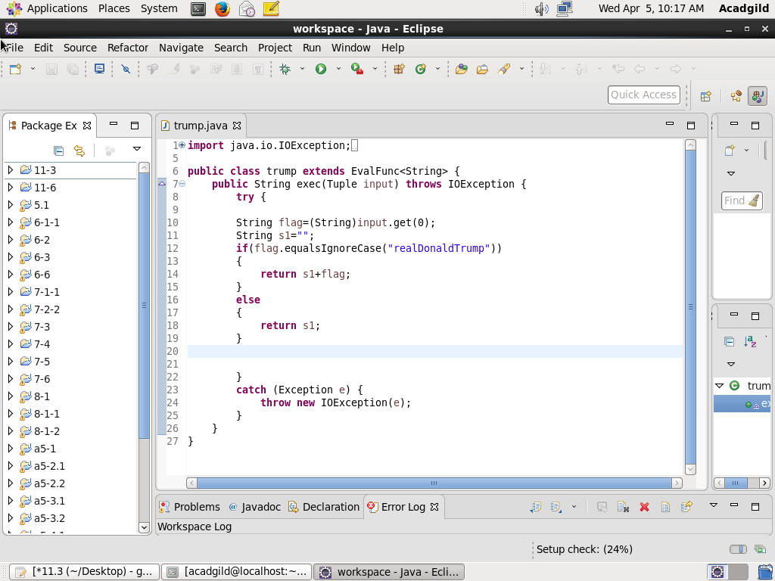

**PIG SCRIPT:**

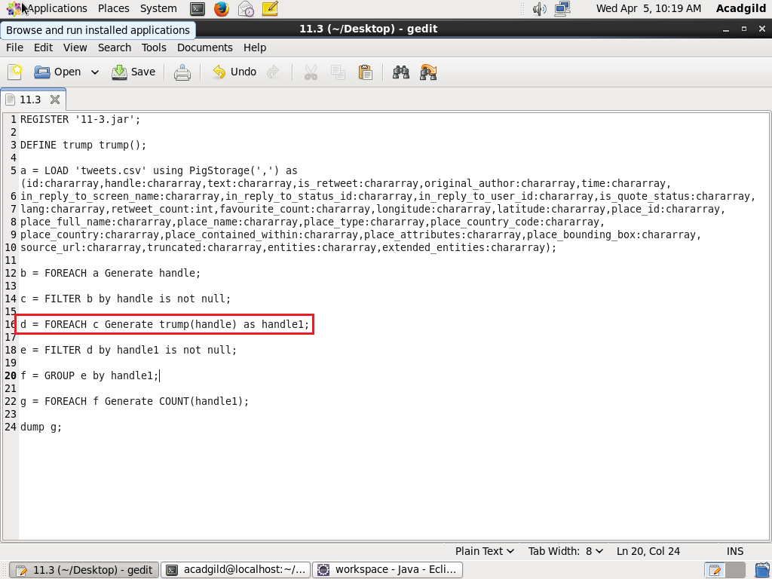

**OUTPUT:**

